travel sop - traveler

Purpose
- This guideline provides instructions for employees embarking on travel with the Office of the Ombudsman. It provides instructions on the various tasks the traveler must complete throughout the travel process.

Scope
- This guideline applies to employees of the Office of Ombudsman for the Department of the National Defence and the Canadian Forces (DND/CF).

Associated Documents/ Templates
- FinCS Instructions for HRG/STSP Self -Registration
- National Joint Council (NJC) Travel Directive
- Individual Travel Authorization (DND 2999) Form (local travel)
- Record of Travel Expenses Form (please see forms section in o:drive)
- ANNEX A: Traveler Checklist
- Memorandum on Travel, Hospitality, Conference and Event Expenditures (THCEE) April 2015
- Event/Hospitality Request Form
- Training Registration SOP
- Event and Hospitality SOP

Contacts
- Travel Arranger
- Finance team (backup)

Roles and Responsibilities
- Becoming familiar with the provisions of the Travel Directive hosted by the NJC. (This is the reference document for all travel)
- Requesting BMO MasterCard Individual Designated Travel Card (IDTC)
- Self-registering to the HRG/STSP (Hogg Robinson Group – Shared Travel Services Portal) This will allow the traveller to get access to the Online Booking Tool (OBT)
- Registering for the online training that is available through the HRG/STS portal
- Travel Card monthly statements are only available online and it’s the responsibility of the Travel Card user to check their statements online on a monthly basis.
- Keeping their HRG/STS profile up to date
- Making payments to their Travel Card

Operating Procedures/Principles OR Protocol OR Services

Expenditure Initiation

Ensure you have the appropriate authority level’s approval to move forward with the travel arrangements. The traveler should email their manager outlining the trip goals, destination, dates, why it is not feasible to use video/teleconference.
- Local Travel ( Within 100km)
  - Fill out the DND 2999 Form
  - Sign under Certification of traveler;
  - Obtain supervisor’s signature under Recommended;
  - Obtain signature of the RC Manager with authority over the cost center that is being charged
- Outside Local Travel (Outside 100km)
  - Fill out DND 2999 Form
  - Fill out Event/Hospitality Form
  - Under Part 4 – Approval obtain the signature of the Ombudsman, and the relevant manager(s).

Self-Registering – HRG/STS Portal
- While travelling on Government business, all travellers must have a unique Traveller Identification Number (TIN)*
*Please do not confuse this with the Travel authorization Number (TAN) or the TAN Prefix-it is not the same

- Before Self-registering please go to Fin CS Travel and Hospitality page to familiarize yourself with how to register for your TIN. Under “How to register for your TIN” Click on the link for ‘traveller’:
Link: Before traveling | TIN TAN Visas Passports | Policies Procedures | Fin CS

- To self-register to the HRG/STSP, open your internet browser and go to the HRG worldwide webpage to register for your TIN
Link: https://isuite6.hrgworldwide.com/gclanguage/en-ca/home.aspx
  - Click Register and follow instructions
  - Fill in all mandatory fields
  - Pay particular attention and select the following when prompted
    - Rank: Civilian
    - Travel Type: Employee
    - Capability Component: Ombudsman
    - Tan prefix: AAU4
  - Please designate your travel arranger when prompted
    - Select two arrangers, this will enable them to finalize your travel arrangements
    - Include Financial Officer as one of the two arrangers
    - Choose; Staff Officer to Ombudsman or A.A. to DG Ops as primary arranger
  - The BMO MasterCard IDTC number must be included in their profile. If they are not using their BMO MasterCard IDTC then their personal credit card number is to be entered in their profile. Note: The Travel Arranger will not be able to reserve the e-tickets without a credit card number in HRG/STS.

Training Portal – Hogg Robinson Group/Shared Travel Services Portal
- This tool is available to help employees learn how to use HRG/STS to build an itinerary and find expense estimates
- Log on to the HRG/STS profile and select training
- Select Training Portal Document
- Follow instructions in the document to create training profile
- Once logged in, Click on (Enrolments or Catalog) on the left menu and you will find two course modules that are applicable. Complete both.
  - Module 1 – STS Introduction
  - Module 2 – Creating a Travel Itinerary –OBT

ClaimsX
- ClaimsX can be found through the internet browser under favourites.
  - Select the DND pre-set favourites and select ClaimsX
- Ensure you have created your account in ClaimsX (same as PC Login info)
- Provide void cheque to travel arranger to add to your ClaimsX profile

Travel Card Program (BMO MasterCard IDTC)
- The individual designated travel card is the recommended method of payment to be used by employees while on travel status.
- To apply go to the HRG/STS website
https://isuite6.hrgworldwide.com/tabid/323/Default.aspx
  - Login to your personal HRG/STS portal with information created in the previous section
- Click on “Travel Card” then click “Apply for an IDTC”
  - Follow instructions and fill in mandatory fields and pay particular attention to the following when prompted:
    - Department Agency: Select DND/MDN from the scroll menu
    - Branch, Sector Group Capability Component (CC) :8I (8 +capital i)
    - Region: PON is 010
    - Responsibility Centre: Select your cost centre from below:
- Ombudsman Cost Centres:
Executive Office | 0162BE | Operations | 0162BJ
Corporate Services | 0162BS | Intake | 0162BM
Communications | 0162BG | Investigations | 0162BP
Central Services | 0162BF | Systemic Investigations | 0162BR

During Travel
- Please make sure to always carry with you:
  - e-Ticket
  - Itinerary
  - Your government BMO MasterCard IDTC
  - Your government I.D. (Not the building pass. Use your ND121)
  - Your passport if travelling outside of Canada
  - Keep all receipts
- Please note that once travel is booked any changes made during travel that incur a cost will require written approval with justification from the manager before the cost is incurred or as soon as possible thereafter in an emergency situation.

After Travel
- Prepare a record of travel expenses within 5 days of travel completion
  - Then submit the completed Record of Travel Expenses to the travel arranger with attached receipts or any other supporting documents
- Check to see if you have been reimbursed within 5-10 business days after your claim was approved by the delegated authority
- After receiving reimbursement pay off your BMO IDTC balance

Work Flow (Service Standards and Routings)
- Traveler is to determine travel dates
- Search HRG’s online booking tool for estimates and itinerary
  - Print all details
- Choose your transportation, car rental and hotel preferences
- Provide all information to travel arranger so they can finalize travel plans, purchase e-ticket and make the appropriate reservation with the TAN.

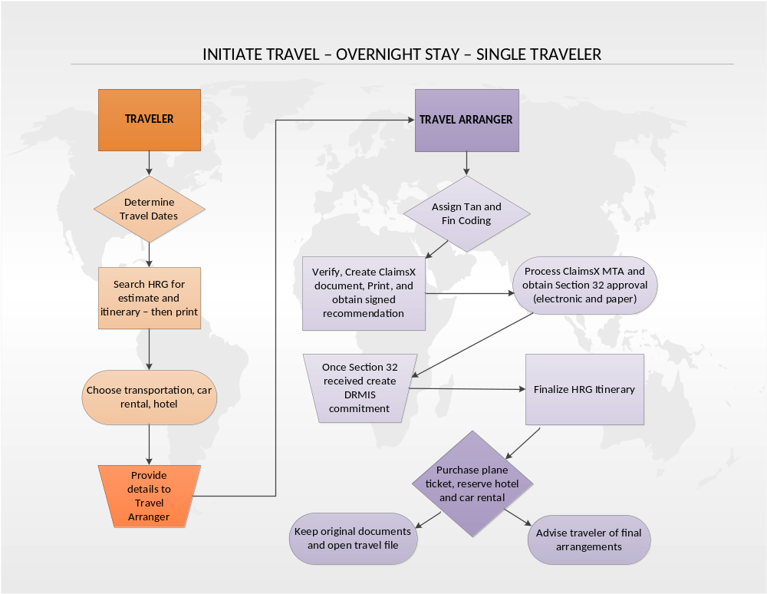

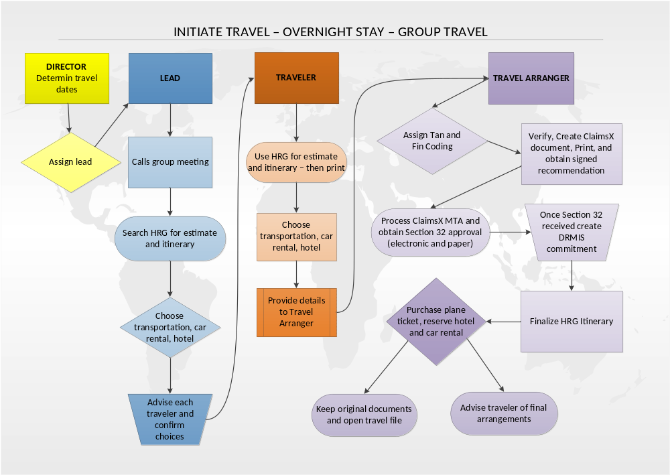

ANNEX A

TRAVELER CHECKLIST
Step | Description | (√)
Expenditure Initiation
1 | Did the traveler get expenditure initiation from the proper authority?
2 | Did you complete an event/hospitality form for travel outside the local area? (> 100 km) If yes;
2 | » Was the completed event/hospitality form signed by the appropriate initiation "Travel" authority? (Ombudsman)
3 | Did you complete a DND 2999 form? (G:\FINANCE\Forms\THCEE) If yes; was the completed DND 2999 form signed by;
3 | » The traveler under Certification of traveler.
3 | » The traveler's supervisor under Recommended.
3 | » The RC Manager with authority over the cost centre being charged under Authorization.
HRG Shared Travel Services Portal
4 | Did you create your HRG profile?  Traveler Identification Number (TIN): ___________________
5 | Did you make a request for the individual designated travel card? (BMO IDTC) Please make sure the travel card information is part of the traveler's profile.
6 | Did you give the Travel Arranger access to your HRG profile?  *If required, they will be able to modify your profile.
7 | Did you use the Online Booking Tool (HRG STS Portal) to create a travel itinerary with cost estimates?
8 | Did you provide a printout of your HRG itinerary and your expenditure initiation e-mail (or other) to the travel arranger?
ClaimsX
9 | Did you create a ClaimsX profile? (same login as DWAN account)
10 | Did you provide a void cheque to the travel arranger to add to your ClaimsX profile?
During travel
11 | Please make sure to "always" carry your:  » e-Ticket  » Itinerary  » Your government BMO IDTC  » Your government I.D.  » Your passport if travelling outside of Canada  » Keep all receipts
After travel
12 | Did you prepare a Record of Travel Expenses? (within 5 days of travel completion)
13 | Did you submit the completed Record of Travel Expenses to the travel arranger with attached receipts or any other supporting documents?
14 | Did you receive your reimbursement within 5-10 business days after your claim was approved by delegated authority? (Final approval stage)
15 | After receiving reimbursement, did you pay off your BMO IDTC balance?

Glossary of Terms
The following is the glossary of acronyms used in this document.

A.A | Admin Assistant
BMO | Bank of Montreal
DG | Director General
DND | Department of National Defence
FinCS | Finance Corporate Services
HRG | Hogg Robinson Group (online booking tool for travel)
IDTC | Individual Designated Travel Card
MDN | Ministère de la Défense nationale
NJC | National Joint Council
OBT | Online Booking Tool
RC | Responsibility Centre
STS | Travel Authorization Services
STSP | Travel Authorization Services Portal
TAN | Travel Authorization Number
THCEE | Travel, Hospitality, Conference and Event Expenditures
TIN | Travel Identification Number

